INSTALLING UBUNTU
Step 1: Enabling WSL and Virtualization for Ubuntu Installation
Windows Subsystem for Linux (WSL) enables users to run Linux distributions directly within Windows without using a virtual machine or dual boot configuration.
Before installing Ubuntu, WSL and hardware virtualization must be enabled through BIOS settings and Windows features.
Step 2: Downloading and Installing Ubuntu Distribution
This step involves downloading and installing the Ubuntu Linux distribution through the Windows Subsystem for Linux platform by opening the command prompt as admin.
Command to Run:
wsl --install -d ubuntu
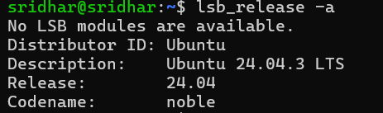
Step 3: Opening Ubuntu and Installing Docker
This step involves launching the Ubuntu terminal and installing Docker, which is used to create and manage containers for application deployment.
Command to Run:
sudo apt install docker.io

Step 4: Updating System Packages
This step updates the Ubuntu package list to ensure the system has the latest software information and security updates.
Command to Run:
sudo apt update
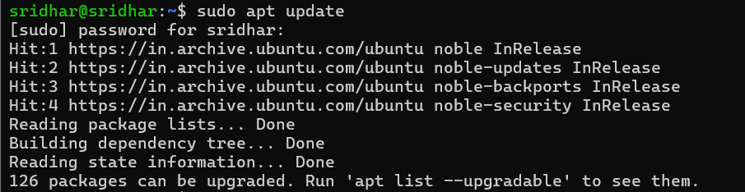
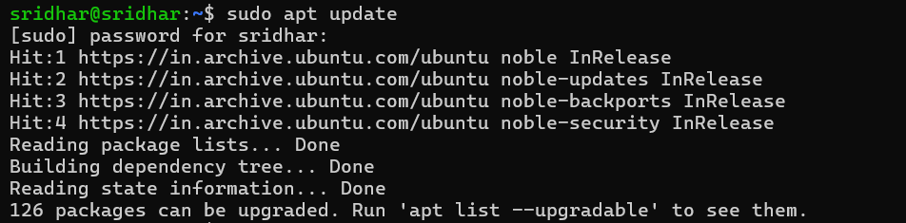

Step 5: Starting Docker Service
This step starts the Docker service in Ubuntu, allowing the system to run and manage containers.Starting the service ensures Docker is active and ready to execute container-based applications.
Command to Run:
sudo systemctl start docker

Step 6: Stopping Docker Service
This step stops the Docker service when container execution is not required.
Stopping the service helps conserve system resources and allows safe system maintenance.
Command to Run:
sudo systemctl stop docker

Step 7: Checking Running Docker Containers
This step is used to view the list of currently running Docker containers in the system.It helps monitor active container processes and verify whether containers are functioning properly.
Command to Run:
sudo docker ps

